**Chapter 4**

**PRESENTATION, ANALYSIS AND INTERPRETATION OF DATA**

This chapter presents the actual data, statistical analysis and interpretation gathered by the researchers based on the data collected from the evaluator’s feedback. The respondents were composed of two hundred (220) students and two (2) admin staff of Concepcion Holy Cross College, Inc. College Department. Data gathered from survey questionnaires were organized in table to reflect the reaction from the respondents.

|  |  |  |
| --- | --- | --- |
| **Table 3.1 Classification of the Respondents** | | |
|  | **Frequency** | **Percentage** |
| Students | 220 | 99.09% |
| Admin Staff | 2 | 0.91% |
| **Total** | **222** | **100%** |

1. **The Existing Enrollment system of Concepcion Holy Cross College, Inc.**

The researcher tabulated the responses from the distributed questionnaires for gathering substantial information that served as basis of developing the proposed system. In this section, graphical representations and descriptive statistics are provided to support the data gathered. The respondents, a total of 222, were the college students and admin staff of Concepcion Holy Cross College, Inc.

**1.1 Concepcion Holy Cross College, Inc. Current Mode of Enrollment System**.

Respondents were asked to mark the currently used enrollment system of the school.

|  |  |  |
| --- | --- | --- |
| **Table 3.2 Current Mode of the Concepcion Holy Cross College, Inc. Enrollment System** | | |
|  | **Frequency** | **Percentage** |
| Manual | 0 | 0 % |
| Semi-Computerized | 222 | 100 % |
| Fully Computerized | 0 | 0 % |

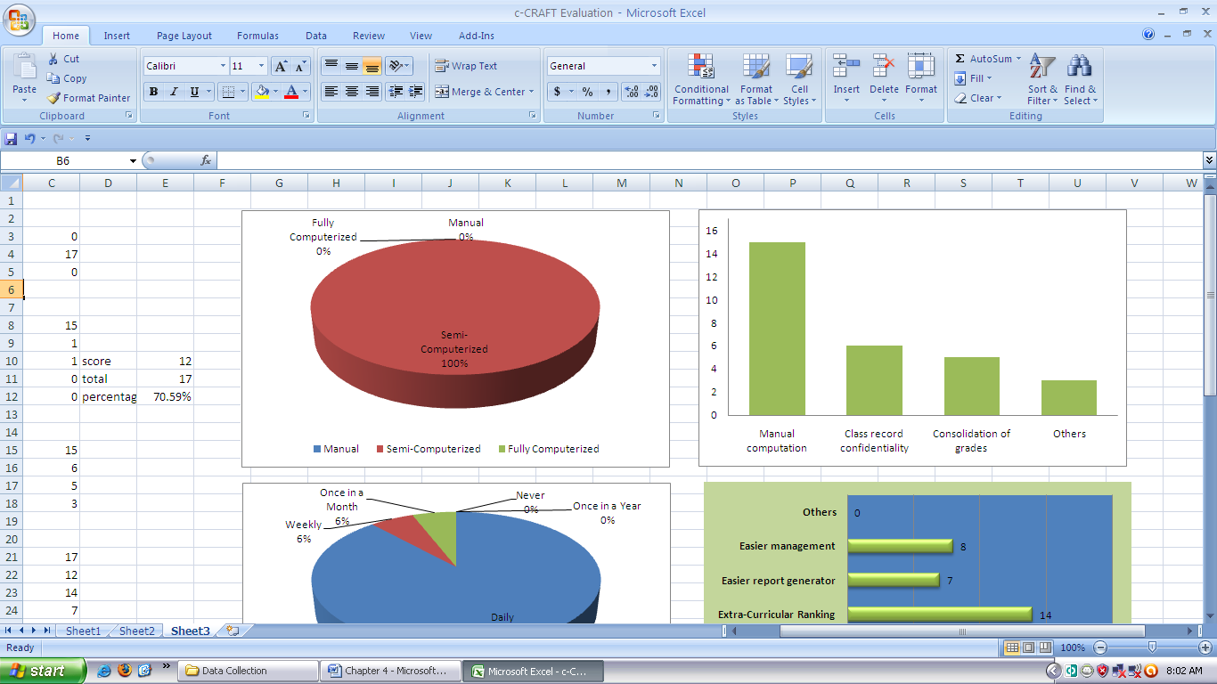

**Figure 3.1 Current Mode of the Concepcion Holy Cross College, Inc. Enrollment System**

Figure 3.0 and Table 3.2 shows that 222 of the respondents of them marked that the enrollment system used in the school is semi-computerized. Therefore, the Concepcion Holy Cross College, Inc. uses a semi-computerized mode of enrollment system. The system is composed of a registration form and Microsoft Excel spreadsheet.

**1.3 Context Diagram of the Existing System.** The context diagram of the existing system in Figure 4.2 is presented in analytical tool to identify the scope and boundary for the system and the project to be developed.

Shown in the diagram is the process undergone by the student, the admin staff with the existing system. All students needed to fill out a plenty of forms for registration and they need to copy schedule from the given copy. On the other hand admin staff needed to compute and get all records of student to evaluate student to enroll. Also instructor need time to get their load after enrollment .

Fill out registration form & subjects & schedules

Admin staff

Students

Manualy compute assessment & evaluation

Manualy record grades of student

Get student no

Submit computed raw scores of grad

Instructor

Get copy of load

**Figure 3.2 Context Diagram of the Existing System**

1. **The Problems Encountered by the Student using the Existing System.** The respondentswere asked to select the problems they encounter using their current enrollment system using a registration form.

|  |  |  |
| --- | --- | --- |
| **Table 3.3 Problems Encountered using the Existing Grading System.** | | |
|  | **Frequency** | **Percentage** |
| Filling out plenty of data | 150 | 67.56 % |
| Slow process of enrollment | 20 | 9.00 % |
| Hard to get result of grades | 45 | 18.08% |
| Others | 7 | 3.15 % |

**Figure 3.3 Problems Encountered using the Existing Enrollment System.**

**2.1 Problems Encountered using the Existing Enrollment System.** Figure 3.3 and Table 4.3 shows the problems encountered by the students using the existing system. More than sixty seven percent (67.56%) of them answered that they felt tired after enrollment because of plenty form to fill out. Nine percent (9%) complaining of the slow process of enrollment that could make them more tired while waiting for their assessment while eighteen percent (18%) of them have irritated when they still not get their result in grade after school semester.

**2.2 Features or Functions to be Included in the Proposed System**. The respondents were also asked to select from the given features or functions that they would like to add in the proposed system. Otherwise, the respondents should specify the features of functions if necessary.

|  |  |  |
| --- | --- | --- |
| **Table 3.4 Features or Functions to be Included in the Proposed System.** | | |
|  | **Frequency** | **Percentage** |
| Others | 0 | 0 % |
| Online payment and billing system | 200 | 91% |
| Scheduling system | 20 | 9% |

**Figure 3.4 Features or Functions to be Included in the Proposed System.**

Table 3.4 and Figure 3.4 show the features or functions that the respondents would like to be included in the proposed system. Most of them wanted to include them like to include billing in the proposed system to make their balance accessible while others want to include scheduling system that could settle automatically all the schedules per classes.

**3. Design and Development of the Proposed System**

* 1. **Requirements Gathering and Refinement**

From these, the researcher identified the users for the system and what are the necessary elements and components concerned with the system such as enrollment reports. The researcher also identified the roles of such users and the limits of their privileges by the degree of their positions within the system.

* 1. **Quick Design**

Based from the context diagram of the existing system the researcher were able to come up with another context diagram for the developed system (See Figure 4.5) that guided the group for building the prototype of the system.

As shown in the figure 4.6 students does not need to record their schedules during enrollment because the proposed system will provide schedules for them in their account online. Also the staff does not need to compute the cost of enrollment manually and evaluate student. The proposed system already evaluates students during enrollment. The system has an access account per student to access their grades online. Instructors could also input the grades of their pupils online.

**Fill out registration form**

Admin staff

Students

**Get evaluation and computed assesment**

**Accessing of grades**

**Access of grades**

**Get student no and password**

**Submit computed raw scores of grade online**

Instructor

**Check load from an account**

**Figure 3.5 Context Diagram of the Proposed System**

* 1. **Building Prototype**



**Figure 3.6 Initial Prototype of the Proposed System (Main Window)**

Shown in Figure 3.6 is the initial prototype built by the proponent that will be evaluated by the client. It shows the visual presentation of the software side of the system to be developed and its components.

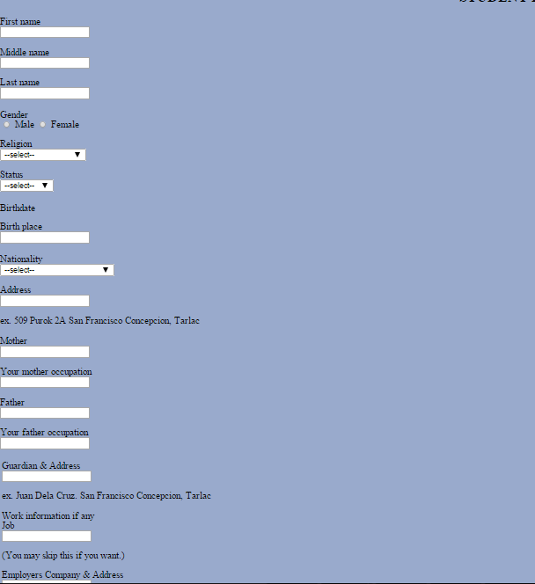

**Figure 3.7 Initial Prototype of the Proposed System (Registration Window)**

The registration window, as seen in Figure 3.7 the student could register through online and get registration number to enroll.

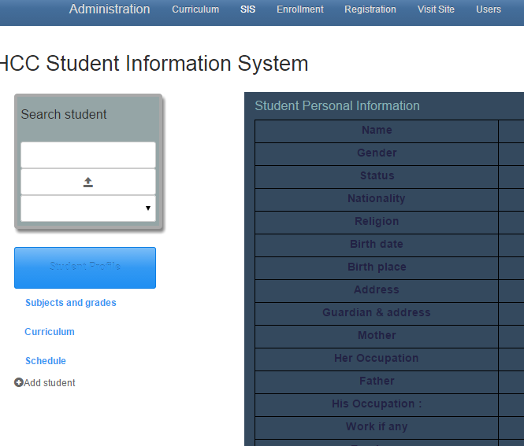

**Figure 3.8 Initial Prototype of the Proposed System (Students Window)**

The students’ window (see Figure 3.8) enables the administrator manage records of students such as viewing grades of every students check their schedule and could add and edit data.

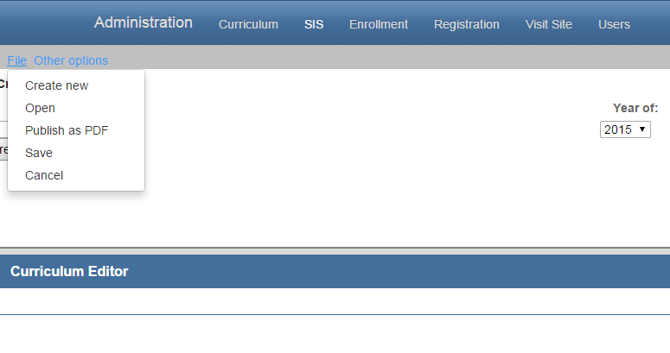

**Figure 3.9 Initial Prototype of the Proposed System (admin window)**

In figure (3.9) which in the admin window an admin staff could make curriculum, courses and subjects to use in enrollment process.

* 1. **Client Evaluation of Prototype**

After a continuous evaluation, the proponent gathered a collection of suggestions and specifications throughout the iterations of evaluation from the client:

* Log in panel should show first before the accessing the admin window
* It should have access of every students record and editing their data.
* It should have a filter pane for searching specific subjects and students instructors, and enrollment transactions.
  1. **Refining Prototype**

Based on the students’ evaluation, the developers now then refined the software according to the specifications of the client and provide another quick design for another prototype to be built and evaluated. This allowed for particular operations to be tested and refined without the enormous effort that would be required if a design were to be implemented.

In Figure 3.10 shows the Log Window prototype as specified by the client. The user will initially view this screen that allows user to log in and input username and password. With this, unauthorized users will not be able to view the student window.



**Figure 3.10 Refined Prototype of the Study (Log Window)**

Refinements of the prototype were done continuously to reach the desired outcome by the clients. Content and computation verification are constantly consulted to the clients to provide accurate and reliable results on data in format.



**Figure 3.11 Refined Prototype of the Study (Main Window)**

In figure 3.11 shows the home page of the prototype of proposed system. page have consisted of menu to be use by users in different purposes or task.

* 1. **Engineered Product**

After a finite number of iterations, the final system was ready for implementation. In this methodology, the system was evolved as a result of **periodic shuttling of information between the client and developer**. The system was ready for evaluation by the users – students and admin staff. After the finalizing the system, the developers laid out an implementation pla that provides a systematic process for system use. Installation, training of users, and system evaluation were undergone for the system to be ready for use.

Based on from the refinement of the prototype, the developers built the final interface and functions of the software as specified by the user’s specifications and needs. In Figure 3.12, it shows the final log in window for the system. The students log in window would be the user’s gateway to access the system by username and password authentication.



**Figure 3.12 Final Student’s Log In Window**

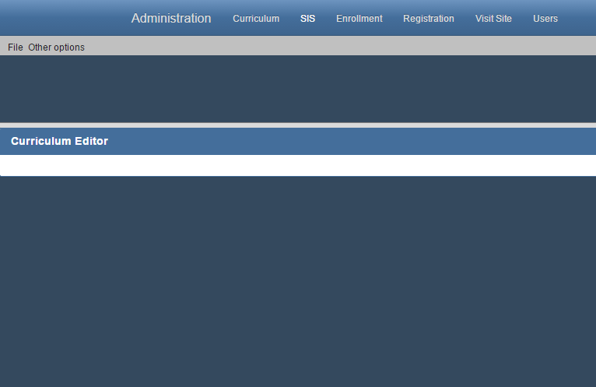

**Figure 3.13 Admin window**

Based from the necessary requirements in hardware and software for the system, the proponents have evaluated the client’s existing computer resources. Upon visiting and checking the computer resources of the client, the researcher found out that all of the client’s computer resources are able to meet at least if not the recommended requirements needed for the system.

**Hardware Specification.** Table 3.5 specifies the basic hardware requirements needed to run the proposed system. One could refer to this table to know what requirements had transpired during the development of the proposed system. The hardware specification is required since it is connected to the system requirements of the proposed system.

|  |  |  |  |
| --- | --- | --- | --- |
| **Components** | **Minimum** | **Recommended** | **Used** |
| Processor | Intel core IE 3 | Intel core IE 3 or Higher | Intel core IE 3 |
| RAM Memory | 2Gb | 2 Gb or Higher | 2 Gb |
| Hard Disk Space | 100 Gb | 60 Gb or Higher | 250 Gb |
| Video Card | 64 Mb | 1 Gb or Higher | 64 Mb |
| LAN Card | 10Mbps | 100Mbps | 100Mpbs |
| Wireless LAN Card | 54Mbps | 54Mbps | 54Mbps |
| Mouse | PS/2 Compatible | USB Compatible | PS/2 Compatible |
| Keyboard | PS/2 Compatible | USB Compatible | PS/2 Compatible |

**Table 3.5 Hardware Specification**

**Software Specification.** Table 3.6 specifies the software needed in implementing the proposed system.

|  |  |  |  |
| --- | --- | --- | --- |
| **Software** | **Minimum** | **Recommended** | **Used** |
| Operating System | Microsoft Windows  7 | Microsoft Windows  7 | Microsoft Windows  7 |
| Browser | Google Chrome,Mozzilla Firefox,Opera | Google Chrome latest | Google chrome |

**Table 3.6 Software Specifications**

**4. Evaluation of the Existing and Developed System**

Feedback from the students’ and admin staff was separately shown. The data were logically grouped into different criteria and type of respondent to identify the levels of responses from each group. Weighted mean for each response was computed with 1 point each.

The existing and developed system was evaluated through based on three general criteria: Security, Efficiency and Reliability. Weighted mean and average weighted mean for each response on specific criteria were computed according to the scoring points provided for the designed Rubrics method used.

**4.1 Evaluation Summary of the Existing System**

Table 3.8 shows the evaluation summary of the existing system in terms of Security. Based from the responses, the existing system is generally poor in terms of security. The respondents find it that the system is not quite secured enough especially in data access of records and limitations on controls using the current system.

|  |  |  |  |  |  |
| --- | --- | --- | --- | --- | --- |
| **Table 3.8 Evaluation of the Existing System in Terms of Security.** | | | | | |
| **Respondents** | | **No. of Respondents** | **Score** | **Mean** | **Verbal Equivalent** |
| **Criteria: Security** | |  |  |  |  |
| 1. | Students | 220 | 234 | 1.064 | Poor |
| 2. | Admin staff | 2 | 2 | 0.00 | Poor |
| **Weighted Mean** | | | | **1.054** | Poor |

Table 3.9 shows the evaluation summary of the existing system in terms of efficiency. It shows that the existing system is poor in terms of efficiency. According to the respondents, the existing system was very hard to handle and organizes since all data were written and keep physically.

|  |  |  |  |  |  |
| --- | --- | --- | --- | --- | --- |
| **Table 3.9 Evaluation of the Existing System in Terms of Efficiency.** | | | | | |
| **Respondents** | | **No. of Respondents** | **Score** | **Mean** | **Verbal Equivalent** |
| **Criteria: Efficiency** | |  |  |  |  |
| 1. | Students | 220 | 246 | 1.118 | Poor |
| 2. | Admin staff | 2 | 2 | 0.000 | Poor |
| **Weighted Mean** | | | | **1.107** | Poor |

Table 3.10 shows the evaluation of the existing system in terms of Reliability. It shows that the existing system is poor in terms of reliability. The respondents differ from their responses based on accuracy and completeness of the information given by the system.

|  |  |  |  |  |  |
| --- | --- | --- | --- | --- | --- |
| **Table 3.10 Evaluation of the Existing System in Terms of Reliability.** | | | | | |
| **Respondents** | | **No. of Respondents** | **Score** | **Mean** | **Verbal Equivalent** |
| **Criteria: Reliability** | |  |  |  |  |
| 1. | Students | 220 | 260 | 1.182 | Poor |
| 2. | Admin | 2 | 2 | 2.000 | Poor |
| **Weighted Mean** | | | | **1.189** | Poor |

|  |  |  |  |
| --- | --- | --- | --- |
| **Table 3.11 Evaluation Summary of the Existing System** | | | |
| **Criteria** | | **Weighted Mean** | **Verbal Equivalent** |
| 1. | Security | 1.054 | Poor |
| 2. | Efficiency | 1.107 | Poor |
| 3. | Reliability | 1.189 | Poor |
| **Average Weighted Mean:** | | **1.116** | **Poor** |

As presented in the evaluation summary of the existing system in Table 3.11, it has met a poor remark with an average weighted mean of 1.116 based on the Lickert’s scale. It is unanimously poor in terms of security and efficiency and relatively satisfactory in terms of reliability.

**4.2 Evaluation Summary of the Developed System**

Table 3.12 shows the evaluation of the developed system in terms of Security. Based from the responses, the system is generally Very satisfactory in terms of security. The respondents find it that the system is secured especially in data access of records and limitations on controls. It has also provided a user authentication feature that would filter the users viewing settings to limit the access and control of keys of the developed system.

|  |  |  |  |  |  |
| --- | --- | --- | --- | --- | --- |
| **Table 3.12 Evaluation of the Developed System in Terms of Security.** | | | | | |
| **Respondents** | | **No. of Respondents** | **Score** | **Mean** | **Verbal Equivalent** |
| **Criteria: Security** | |  |  |  |  |
| 1. | Students | 220 | 810 | 3.682 | Very Satisfactory |
| 2. | Admin | 2 | 10 | 5.000 | Very Satisfactory |
| **Weighted Mean** | | | | **3.693** | **Very Satisfactory** |

Table 3.13 shows the evaluation of the developed system in terms of Efficiency. It shows that the existing system is very satisfactory in terms of efficiency. According to the respondents, the developed system is easy to use for organizing student information and other important data.

|  |  |  |  |  |  |
| --- | --- | --- | --- | --- | --- |
| **Table 3.13 Evaluation of the Developed System in Terms of Efficiency.** | | | | | |
| **Respondents** | | **No. of Respondents** | **Score** | **Weighted Mean** | **Verbal Equivalent** |
| **Criteria: Efficiency** | |  |  |  |  |
| 1. | Students | 220 | 801 | 3.642 | Very Satisfactory |
| 2. | Admin | 2 | 10 | 5.000 | Very Satisfactory |
| **Average Weighted Mean** | | | | **3.654** | **Very Satisfactory** |

Table 3.14 shows the evaluation of the developed system in terms of Reliability. It shows that the developed system is very satisfactory in terms of reliability. The respondents agree that the developed system is reliable. It shows that it can provide accurate computation of assessment during enrollment.

|  |  |  |  |  |  |
| --- | --- | --- | --- | --- | --- |
| **Table 3.14 Evaluation of the Developed System in Terms of Reliability.** | | | | | |
| **Respondents** | | **No. of Respondents** | **Score** | **Mean** | **Verbal Equivalent** |
| **Criteria: Reliability** | |  |  |  |  |
| 1. | Students | 220 | 785 | 3.568 | Very Satisfactory |
| 2. | Admin | 2 | 6 | 3.000 | Very Satisactory |
| **Weighted Mean** | | | | **3.562** | **Very Satisfactory** |

Presented in Table 3.15 is the evaluation summary of the developed system. It has an average weighted mean of 3.562 that is verbally equivalent to very satisfactory which shows that the developed system is very satisfactory in terms of security, efficiency and reliability.

|  |  |  |  |
| --- | --- | --- | --- |
| **Table 3.15 Evaluation Summary of the Proposed System** | | | |
| **Criteria** | | **Weighted Mean** | **Verbal Equivalent** |
| 1. | Security | 3.693 | Very Ssatisfactory |
| 2. | Efficiency | 3.654 | Very Satisfactory |
| 3. | Reliability | 3.562 | Very Satisfactory |
| **Average Weighted Mean:** | | **3.636** | **Very Satisfactory** |

**4.3 Evaluation Summary of the Existing and Proposed System**

Shown in Figure 4.14 is the graphical presentation of the results acquired from the evaluation of the existing and developed system in terms of security, efficiency and reliability. The figure clearly shows that the developed system is operationally feasible for implementation.

**Figure 3.14 Evaluation Summary of the Existing and Developed System**

Shown in Table 3.16 are the evaluation summary of the existing and the developed system. Based from the results, the existing system is rated as generally good as a system. On the other hand, the developed system is generally excellent as a class record and grading system in terms of security, efficiency and reliability.

|  |  |  |  |  |  |  |  |
| --- | --- | --- | --- | --- | --- | --- | --- |
| **Table 3.16 Evaluation Summary of the Existing and Developed System** | | | | | | | |
| **Existing System** | | | | **Developed System** | | | |
| **Criteria** | | **Weighted Mean** | **Verbal Equivalent** | **Criteria** | | **Weighted Mean** | **Verbal Equivalent** |
| 1. | Security | 1.054 | Poor | 1. | Security | 3.693 | Very Ssatisfactory |
| 2. | Efficiency | 1.107 | Poor | 2. | Efficiency | 3.654 | Very Satisfactory |
| 3. | Reliability | 1.189 | Poor | 3. | Reliability | 3.562 | Very Satisfactory |
| **Average Weighted Mean:** | | **1.116** | **Poor** | **Poor** | | **3.636** | **Very Satisfactory** |

From these results, the data was treated with Student’s t-test to test the formulated hypothesis. Since the value of t-computed (tc) which is 129.46 is greater than the t-tabulated (tt) which is (1.96); whose calculation can be seen on the computation of t-test (see Appendix I), the null hypothesis would be rejected, and the alternative hypothesis would be accepted.